https://app.diagrams.net/#G1c1MEHFWrfSOWexhouYqk9HA6wB4_u2pl#%7B%22pageId%22%3A%22-UYV5KzmVbv8xHgSMJTf%22%7D
StudentProfile
3.1.1 – 3.1.3.-CD StudentProfile Class Diagram
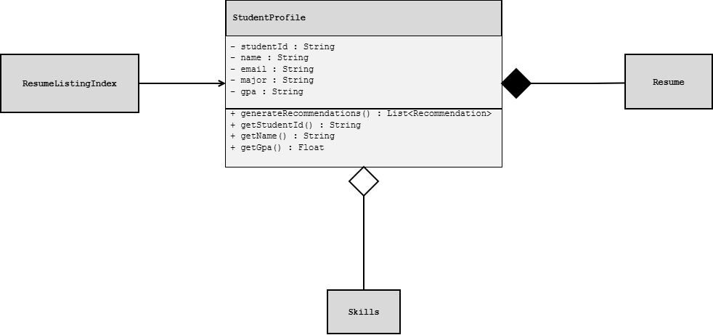

JobPosting
2.5.1 – 2.5.9-CD JobPosting Class Diagram
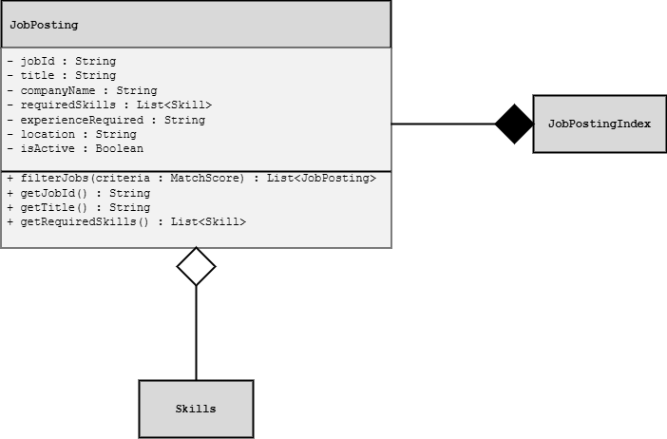

Recommendation
2.3.7, 3.3.3-CDRecommendation Class Diagram
